

**International School**

**Capstone Project 2**

**CMU-SE 451 – C2SE.12**

**Architecture Design**

**Version 1.1**

**Date: March 6th, 2021**

**Learn English Together**

**Submitted by**

**Ha, Le Thanh**

**Hieu, Le Xuan**

**My, Ngo Ngoc**

**Thong, Doan Trung**

**Approved by**

**MSc Huy, Truong Dinh**

**Proposal Review Panel Representative:**

Name Signature Date

**Capstone Project 2- Mentor:**

Name Signature Date

**PROJECT INFORMATION**

|  |  |  |  |
| --- | --- | --- | --- |
| **Project acronym** | LET | | |
| **Project Title** | Learn English Together | | |
| **Start Date** | 26 Feb 2021 | **End Date** | 08 Jun 2021 |
| **Lead Institution** | International School, Duy Tan University | | |
| **Project Mentor** | MSc Huy, Truong Dinh | | |
| **Scrum master / Project Leader & contact details** | Ha, Le Thanh  Email: lethanhhadtu@gmail.com  Tel: 0334002818 | | |
| **Partner Organization** | Duy Tan University | | |
| **Project Web URL** |  | | |
| **Team members** | Name | Email | Tel |
|  | Ha, Le Thanh | lethanhhadtu@gmail.com | 0334002818 |
|  | Hieu, Le Xuan | xuanhieu.le.1999@gmail.com | 0399706614 |
|  | My, Ngo Ngoc | ngongocmy851999@gmail.com | 0764497391 |
|  | Thong, Doan Trung | doanthong002@gmail.com | 0886428208 |

**DOCUMENT APPROVALS**

The following signatures are required for approval of this document.

|  |  |  |
| --- | --- | --- |
| Ha, Le Thanh  Student ID: 2321122516  *Scrum Master* | Signature | Date |
| Hieu, Le Xuan  Student ID: 2321124665  *Team Member* | Signature | Date |
| My, Ngo Ngoc  Student ID: 2321124970  *Team Member* | Signature | Date |
| Thong, Doan Trung  Student ID: 2321124144  *Team Member* | Signature | Date |

REVISION HISTORY

| **Version** | **Date** | **Comments** | **Author** |
| --- | --- | --- | --- |
| 1.0 | March 18th, 2021 | Initial Release | Ngo Ngoc My |
| 1.1 | March 21th, 2021 | Update Current Status of Art | Ngo Ngoc My |

TABLE OF CONTENT

1. Introduction 5

**1.1. Purpose 5**

**1.2. Document reference 5**

2. Project reference 5

**2.1. Project Overview 5**

**2.2. Business Driver 6**

**2.2.1. Business problem 6**

**2.2.2. Business need 6**

**2.2.3. Project goals 6**

3. Architecture Drivers 6

**3.2. System Context 7**

**3.3. Architecture Driver Specification 8**

**3.3.1. Use Case Entities 8**

**3.3.2. Operational Use Case 9**

**3.4. Quality Attributes 13**

4. Constraints 14

**4.1. Business Constraint 14**

**4.2. Technical Constraint 14**

5. High-level Architecture 15

**5.1. Component and Connector View (C&C view) 15**

**5.1.1. Prose 16**

**5.1.2. Role and Responsibility of Elements 17**

**5.2. Module View 18**

**5.2.1. Prose 18**

**5.2.2. Role and Responsibility of Elements 18**

**5.3. Allocation View 21**

**5.3.2. Prose 22**

**5.3.3. Role and Responsibility of Elements 23**

1. Introduction

1.1. Purpose

This specification covers following:

* Brief specification of the project, high level requirement, system context for the system.
* Use case diagram, detail quality attribution.
* Architecture presented by various architecture view types: Component and Connect tor view, Module view and Allocation view.

1.2. Document reference

|  |  |
| --- | --- |
| **No** | **Reference** |
| **1** | C1SE.12_ProductBacklog_ver1.1.docx |
| **2** | C1SE.12_UserStory_ver1.1.docx |
| **3** | C1SE.12_ProjectPlan_ver1.1.docx |

Table 1: Document Reference

2. Project reference

2.1. Project Overview

* Project name: **Learn English Together**
* Development team

|  |  |
| --- | --- |
| **Full name** | **Position** |
| Ha, Le Thanh | Scrum Master |
| Hieu, Le Xuan | Scrum Member |
| My, Ngo Ngoc | Scrum Member |
| Thong, Doan Trung | Scrum Member |

2.2. Business Driver

2.2.1. Business problem

2.2.2. Business need

- Community helps each other learn English.

- Application can learn vocabulary, listen for beginners.

- Application that make learning more efficient by learning in groups.

- The application can interact with others and support each other in learning.

- The application can help, share and inspire others to learn English.

2.2.3. Project goals

LET is an application system that supports and helps lost learners learn English in a natural and exciting way. Learning a new language is like learning your mother tongue, language needs to come naturally. The system will be a community of people with similar interests in learning English, helping and supporting each other to learn English. Good people will tutor friends who are weaker than me to learn English. From there will create a community together to learn and improve English.

3. Architecture Drivers

**3.1. High-level Requirements**

Refer to C1SE.12_ProductBacklog_ver1.1

3.2. System Context

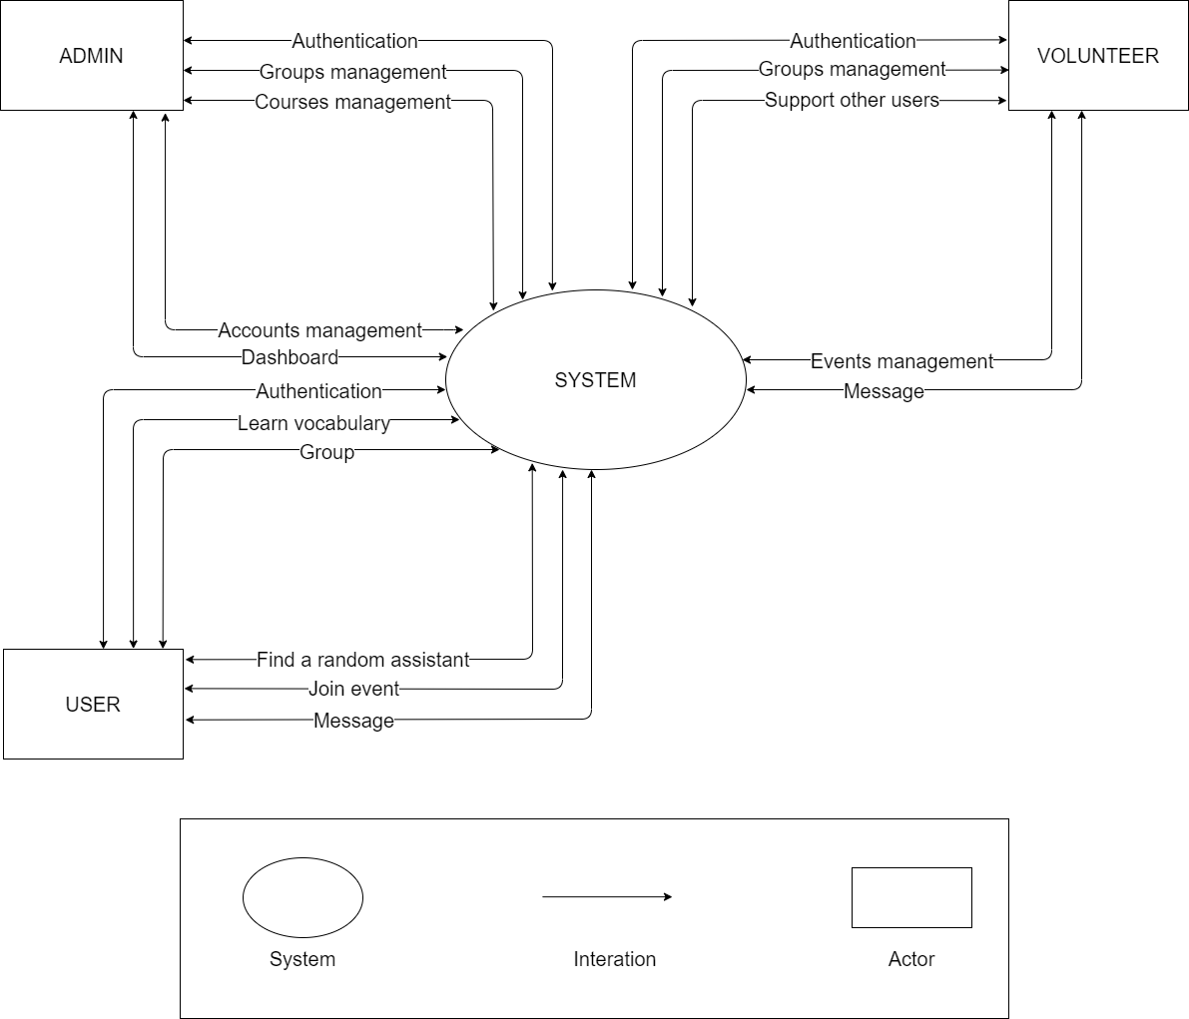

* **Admin:**
  + Admin can authenticate identity (login / logout)
  + Admin can manage groups in the system.
  + Admin can manage accounts in the system (Add, change roles, lock accounts)
  + Admin can create management courses (add default course, edit default courses, block course)
  + Admin can view dashboard chart statistics
* **Volunteer:**
  + Volunteer can authenticate identity (login / logout)
  + Volunteer can manage groups created by them (create, teaching online, create quiz, manage users in group, change group, delete group)
  + Volunteer can receive random assistance from the user in need of assistance (video, audio, text)
  + Volunteers can manage their events (create event, online conference, change event, delete event)
  + Volunteers can interact privately with other users through message
* **User:**
  + User can authenticate identity (login / logout)
  + User can learn vocabulary
  + User can join groups (Study online, take quizzes, review old lesson transcripts, interact with team members)
  + User can find random helpers (video, audio, text)
  + User can join events
  + User can interact privately with other users through message

3.3. Architecture Driver Specification

3.3.1. Use Case Entities

|  |  |
| --- | --- |
| **ID** | E01 |
| **Title** | Admin |
| **Description** | Admin is a person who managing the system. |
| **Provides Assumptions** | Admin is the management of the entire system |
| **Requires Assumptions** | Already have a default account |
| **Identified Use Cases** | UC01, UC02 |

|  |  |
| --- | --- |
| **ID** | E02 |
| **Title** | Volunteer |
| **Description** | Volunteer is a teacher who using the system |
| **Provides Assumptions** | Provide person information (optional) |
| **Requires Assumptions** | Connect the internet |
| **Identified Use Cases** | UC03 to UC5 |

|  |  |
| --- | --- |
| **ID** | E03 |
| **Title** | Student |
| **Description** | Student is a learner who using the system |
| **Provides Assumptions** | Provide person information (optional) |
| **Requires Assumptions** | Connect the internet |
| **Identified Use Cases** | UC05 to UC09 |

3.3.2. Operational Use Case

|  |  |
| --- | --- |
| **ID** | UC01 |
| **Title** | Login |
| **Description** | Login into system |
| **Entities Involved** | E01 |
| **Precondition** | Admin is already has default account. |
| **Primary Flow** | 1. Navigate to Admin System website 2. Choose “Use with Admin” button. 3. Navigate to Login page 4. Fill the form with the default account of the admin 5. Click on “Login” button |
| **Post Conditions** | Already have default account. |
| **Alternate Flows** | In step 4 of the Primary Flow, if [Email]/[Username] or [Password] is incorrect, the system will prompt manager “email or password is incorrect” or “username or password is incorrect”, respectively.  In step 1, 2, 3, 5 of the Primary Flow, if the system has problem, it will show error message. |

|  |  |
| --- | --- |
| **ID** | UC02 |
| **Title** | Manage groups account courses in the system |
| **Description** | Create, Edit, Delete data from database of the system |
| **Entities Involved** | E01 |
| **Precondition** | Successful logged in the admin website |
| **Primary Flow** | 1. Click on [Manage Table] on Sidebar 2. Choose the Table to manage 3. Click on “Add …” button to create new record 4. Click on “Delete …” button to delete all the record had chosen 5. Click on “Edit” icon to show edit modal |
| **Post Conditions** |  |
| **Alternate Flows** | In step 1 of the Primary Flow, if the system has problem, it will show error message.  In step 2 of the Primary Flow  With [Edit]/[Add] option, if the input field be empty, the system will prompt manager “This field not be empty”.  With [Delete] option, the system will prompt user “Do you want to delete this account?”. Click “OK” to delete or click “Cancel” to drop. |

|  |  |
| --- | --- |
| **ID** | UC03 |
| **Title** | Create, change and delete group |
| **Description** | Create, change or delete groups that you manage |
| **Entities Involved** | E02 |
| **Preconditions** | Access the website |
| **Primary Flow** | 1. Open Learning English Together on browser. 2. Press [Group] on menu bar to navigate the group page. 3. Click the plus sign to add the group 4. For each group you want to change, press the edit button and press the delete button if you want to delete the group |
| **Post Conditions** |  |
| **Alternate Flows** | In step 1, 2, 3 of the Primary Flow, if the system has a problem, it will show error messages.  In step 3, 4 of the Primary Flow:  System will send message “Error link” if link is not exist anymore. |

|  |  |
| --- | --- |
| **ID** | UC04 |
| **Title** | Live Stream |
| **Description** | Live stream to teach |
| **Entities Involved** | E02 |
| **Preconditions** | Access the website |
| **Primary Flow** | 1. Open Learning English Together on browser.  2. Press [Group] on menu bar to navigate the group page.  3. Click to select the topic then click to select group  4. Start streaming to teach |
| **Post Conditions** |  |
| **Alternate Flows** | In step 1, 2, 3 of the Primary Flow, if the system has a problem, it will show error messages.  In step 3, 4 of the Primary Flow:  System will send message “Error link” if link is not exist anymore. |

|  |  |
| --- | --- |
| **ID** | UC05 |
| **Title** | Create, change and delete event |
| **Description** | Create events for everyone to discuss you can change or delete the event you create |
| **Entities Involved** | E02 |
| **Preconditions** | Access the website |
| **Primary Flow** | 1. Open Learning English Together on browser. 2. Press [Event] on menu bar to navigate the group page. 3. Create events on this page 4. For each event you want to change, hit the edit button and hit the delete button if you want to delete the event |
| **Post Conditions** |  |
| **Alternate Flows** | In step 1, 2, 3 of the Primary Flow, if the system has a problem, it will show error messages.  In step 3, 4 of the Primary Flow:  System will send message “Error link” if link is not exist anymore. |

|  |  |
| --- | --- |
| **ID** | UC06 |
| **Title** | Join group |
| **Description** | Create, change or delete groups that you manage |
| **Entities Involved** | E02 |
| **Preconditions** | Access the website |
| **Primary Flow** | 1. Open Learning English Together on browser. 2. Press [Group] on menu bar to navigate the group page. 3. Choose the topic you want to join then click the join button |
| **Post Conditions** |  |
| **Alternate Flows** | In step 1, 2, 3 of the Primary Flow, if the system has a problem, it will show error messages.  In step 3, 4 of the Primary Flow:  System will send message “Error link” if link is not exist anymore. |

|  |  |
| --- | --- |
| **ID** | UC07 |
| **Title** | Chat room |
| **Description** | Create, change or delete groups that you manage |
| **Entities Involved** | E02 |
| **Preconditions** | Access the website |
| **Primary Flow** | 1. Open Learning English Together on browser. 2. Press [Group] on menu bar to navigate the group page. 3. Click to select the topic then click to select group 4. Press to join class and chat |
| **Post Conditions** |  |
| **Alternate Flows** | In step 1, 2, 3 of the Primary Flow, if the system has a problem, it will show error messages.  In step 3, 4 of the Primary Flow:  System will send message “Error link” if link is not exist anymore. |

|  |  |
| --- | --- |
| **ID** | UC08 |
| **Title** | Vocabulary |
| **Description** | Create, change or delete groups that you manage |
| **Entities Involved** | E02 |
| **Preconditions** | Access the website |
| **Primary Flow** | 1. Open Learning English Together on browser. 2. Press [Course] on menu bar to navigate the group page. 3. Choose vocabulary course you need to learn |
| **Post Conditions** |  |
| **Alternate Flows** | In step 1, 2, 3 of the Primary Flow, if the system has a problem, it will show error messages.  In step 3, 4 of the Primary Flow:  System will send message “Error link” if link is not exist anymore. |

|  |  |
| --- | --- |
| **ID** | UC09 |
| **Title** | Quiz |
| **Description** | Create, change or delete groups that you manage |
| **Entities Involved** | E02 |
| **Preconditions** | Access the website |
| **Primary Flow** |  |
| **Post Conditions** | 1. Open Learning English Together on browser. 2. Press [Group] on menu bar to navigate the group page. 3. Click to select the topic then click to select group 4. Click to join the class and take the test |
| **Alternate Flows** | In step 1, 2, 3 of the Primary Flow, if the system has a problem, it will show error messages.  In step 3, 4 of the Primary Flow:  System will send message “Error link” if link is not exist anymore. |

* 1. Quality Attributes

|  |  |
| --- | --- |
| **Quality attribute: Usability** | **ID**: QA01 |
| **Stimulus** | Manager interacts with the website.  User interacts with the website. |
| **Source(s) of the Stimulus** | User, Manager |
| **Relevant Environment** | Runtime |
| **Artifact Stimulated** | Website |
| **Response** | System should response fast with smooth animation |
| **Response Measure(s)** | System should response within 4 seconds |

|  |  |
| --- | --- |
| **Quality attribute: Security** | **ID**: QA02 |
| **Stimulus** | Users do not want to disclose sensitive information illegally |
| **Source(s) of the Stimulus** | System |
| **Relevant Environment** | The system is online, connected to network |
| **Artifact Stimulated** | System Database, Server |
| **Response** |  |
| **Response Measure(s)** |  |

|  |  |
| --- | --- |
| **Quality attribute: Modifiability** | **ID**: QA03 |
| **Stimulus** | Manager want to update account or information |
| **Source(s) of the Stimulus** | Manager |
| **Relevant Environment** | Runtime |
| **Artifact Stimulated** | Website |
| **Response** | The system should responses to updated information |
| **Response Measure(s)** | System should response within 3 seconds |

4. Constraints

4.1. Business Constraint

* Project will be started on: Feb 26th, 2021.
* Project will be finished on: May 25th, 2021.
* Project will be finished in 90 days (2880).

4.2. Technical Constraint

* Programming language: JavaScript
* Library: Hook, Redux, React hook form, Font awesome, Material ui, Express.js.
* Technology: ReactJs, Nodejs, Polling, Elasticsearch, Redis, WebSocket, Mail gun.
* Database: Mongo dB.
* Version Control System: GitHub
* Team Management: Trello, Zalo, Google drive
* Develop tools: Visual Studio Code

**Environments:**

* Internet Connection
* Operation System: Google Chrome, Microsoft Edge, CocCoc, Firefox

**Other Constraints:**

* Resource: 4 people.
* Budget: Limited.
* Time: The project must be completed within 03 months.
* These features are not available in the first version of the product.

1. High-level Architecture

5.1. Component and Connector View (C&C view)

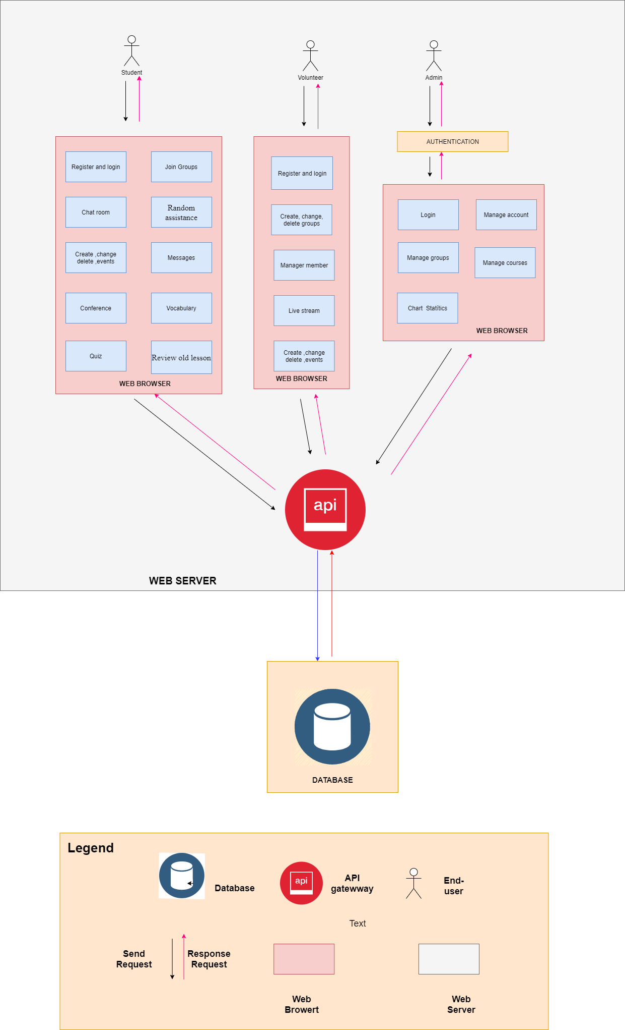

5.1.1. Prose

End-User here is Manager or User uses our system via Web browser, respectively. When users access the system, users will use the features provided. When client-server sending a service request, they will be able to use the system through API Gateway which the main communicate with return all data is retrieved by querying to Database.

5.1.2. Role and Responsibility of Elements

* **End-User** will responsible for sending the request and receiving the response.
* **Authentication** will receive the request from Manager and checks to see if Manager’s credentials match the one in a database of authorized users or in a data authentication server. Then, the request is sent to the Web Browser for processing with the respective Manager.
* **Web Browser** is responsible for processing the End-user's request. It will receive the request from the End-user and present it to the manager as a Website. It includes two modules with different purposes.
* **API Gateway** is responsible for collecting requests from End-User to process by communication to Database by reading and writing data.
* **Database** is a place that stores data and manipulation data of the system. The database will access the Database to take the data to handle some user requests.
  1. Module View

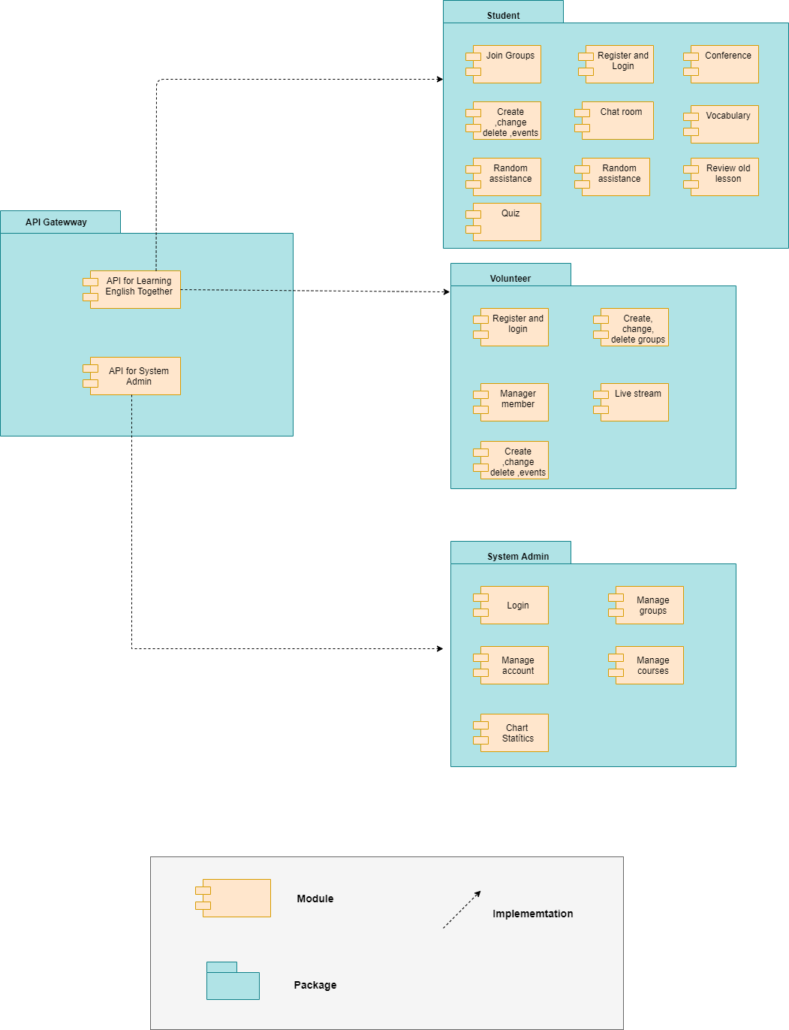

5.2.1. Prose

* To process and authorize request from the user, packages which responsibility for interacting with the user, are tied up together to authorize the association between user and data. All requests come from users firstly will be received by API Gateway. Then, API will handle the request and get necessary data from Database and response respectively.

5.2.2. Role and Responsibility of Elements

* **System Admin package** responsibility for operating the data which was received from API module and presenting to manager as a Website. In this package includes a module with purpose is manage data table from the database.
* **Learning English Together Website package** responsibility for operating the data which was received from API module and presenting to user as a website. In this package includes six modules with different purposes.
* **API Gateway package** responsibility for collecting request from user or manager to process by communication to Data Access module to query data and responding to Learning English Together Website package or System Admin as JSON file. This package includes two modules with different purposes
  + *API for Learning English Together Website module* includes queries which relate to the requests from user to operate the functionals in the Website.
  + *API for System Admin module* includes queries which relate to the requests from manager to operate the functionals in Website.
  1. Allocation View 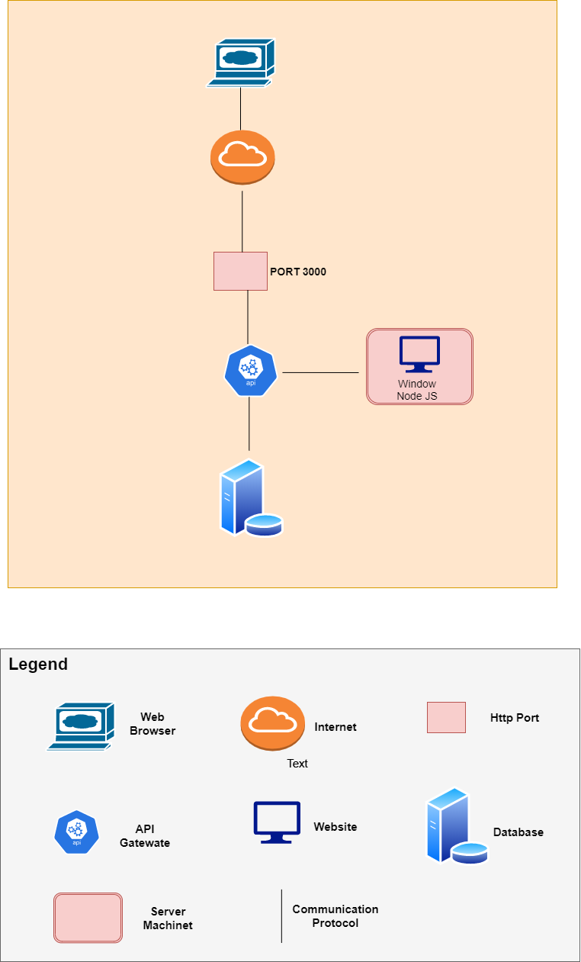

5.3.2. Prose

- End users here are respectively Managers or Users using our system through a Web browser. All requests are processed in a Central Web Server, data access is only made between the Web Server and the Database Server. All transactions between the user and the system will be deployed on Firebase through the API call.

5.3.3. Role and Responsibility of Elements

* **Web Browser** is an interface for managers to interact with the system and submit their requests.
* **API Gateway** is responsible for collecting requests from End-User to process by communication to Database by reading and writing data.
* **Database** is a place that stores data and manipulation data of the system. The database will access the Database to take the data to handle some user requests.
* **Internet** is the communication environment between the website and the server.
* **Website** is the place to receive and process requests from end users.
* **Server machine** is a computer program or device that provides a service to another computer program and its user